**Application of Ensemble Models to Predict the Shear Strength of Concrete Beams Reinforced with Steel Fibres – Structural Health Monitoring Application**



Thesis by –

Nandita Suresh Kamath – 2018B4A20868P

Supervisor – Dr Anupam Singhal, BITS Pilani

Co-Supervisor – Dr Ekin Ozer, UCD Dublin

In Partial Fulfilment of the Requirements for the

Degree of

B.E. Civil Engineering

Birla Institute of Technology and Science, Pilani

**Acknowledgement**

I would like to express my deepest gratitude to my thesis advisor, Dr Anupam Singhal for his unwavering guidance, support, and patience throughout the entire process. Without his expertise and mentorship, this thesis would not have been possible.

I would also like to thank my co-supervisor, Dr Ekin Ozer from University College Dublin for providing me with the opportunity to collaborate through this thesis and introducing me to the concepts of structural health monitoring. Without his expertise and mentorship, this thesis would not have been possible.

My heartfelt thanks go to my family and friends for their unconditional love and encouragement, which kept me motivated and inspired during the most challenging moments of this journey.

**TABLE OF CONTENTS**

|  |  |  |
| --- | --- | --- |
| Sl. No | Chapter Name | Page Number |
| 1 | Abstract | 6 |
| 1 | Introduction | 7 |
| 2 | Traditional Methods of SHM | 9 |
| 3 | Emergence of ML in Structural Health Monitoring | 12 |
| 4 | Literature Review | 15 |
| 5 | Components of ML Powered SHM | 17 |
| 6 | Ensemble Machine Learning | 20 |
| 7 | Case Study | 26 |
| 8 | Results & Conclusion | 35 |
| 9 | Suggestion for Future Work | 36 |

**LIST OF FIGURES**

|  |  |
| --- | --- |
| Sl. No. | Figure Description |
| 1 | Components of SHM |
| 2 | Flowchart Depiction of Bagging Algorithm |
| 3 | Flowchart Depiction of Boosting Algorithm |
| 4 | Flowchart Depiction of Stacking Algorithm |
| 5 | Flow Chart Depiction End-to-End ML Process |
| 6 | Distribution of Target Variables |
| 7 | Distribution of Feature Variables |
| 8 | Heatmap and Correlation Matrix of Features |
| 9 | Performance of each Model |
| 10 | Original vs Predicted Values of Strength |

**LIST OF TABLES**

|  |  |
| --- | --- |
| Sl. No. | Table Description |
| 1 | Definition of Performance Metrics |
| 2 | Features of Existing Dataset |
| 3 | Statistical Analysis of Features |
| 4 | R2 scores of Models |

**Abstract**

This research paper explores the application of machine learning techniques in the field of structural health monitoring (SHM). The objective of SHM is to continuously assess the integrity of structures such as bridges, buildings, and aircrafts, and detect any damage or deterioration before it becomes critical. Machine learning algorithms have shown great potential in addressing the challenges faced by traditional SHM methods, such as dealing with large amounts of data and detecting subtle changes in the structural parameters of complex structural systems. This paper provides an overview of the current state of SHM and its challenges, followed by a discussion of the various machine learning techniques that can be applied to SHM. The paper also presents a case study that demonstrate the effectiveness of machine learning in SHM, and discusses future directions for research in this field. The results of this study show that machine learning can significantly improve the accuracy and efficiency of SHM, and has the potential to revolutionize the way we monitor and maintain our critical infrastructure.

**Chapter 1**

**Introduction**

Engineering structures like beams, building and bridges are key elements to the smooth functioning of society and any unforeseen damage caused by internal or external factors can cause loss of life and wealth. Even though the aging and degradation of such structures are inevitable, it is important to conduct frequent maintenance of such structures to guarantee the safety and reliability of these structures by identifying any underlying damage and help predict any future failures.

This periodic maintenance is either carried out through visual observation or non-destructive evaluation. Visual observation, relying heavily on human capacity poses numerous cons and is only effective for small structures. However, to determine the global behaviour and response of large structures, a non-destructive form of structural health monitoring is applied in most cases. These methods incorporate the benefits of technology and transition damage evaluation from an offline to an online setup.

Structural health monitoring involves the real-time observation and analysis of an engineering structure or system using measurement devices such as sensors. Sensitive features pertaining to the material, geometry, dynamic properties and responses of the structure can help to assess the current performance, document physiological changes and predict any potential damage in the structure.

With the increasing complexity and scale of these structures, traditional monitoring methods have become inadequate, and there is a need for more efficient and accurate techniques. Machine learning has emerged as a viable solution for SHM, with the potential to provide real-time monitoring, early detection of damage, and predictive maintenance.

This thesis aims to review the application of machine learning in structural health monitoring. We first introduce the fundamental concepts of SHM and highlight the limitations of traditional monitoring methods. We then present the basic principles of machine learning, including unsupervised and supervised learning, feature extraction, and model selection. We discuss the different types of data used in SHM, such as vibration, strain, and acoustic data, and the various machine learning algorithms that can be applied to analyse this data.

Next, we review some recent studies that have applied machine learning techniques to SHM, including the use of ridge classification, decision trees, linear support vector machines, and ensemble methods. We discuss the advantages and limitations of these approaches, as well as the challenges and open issues in their practical implementation.

Next, we implement Ensemble ML methods by combining numerous baseline ML models on a dataset to build a more powerful model.

Finally, we conclude by summarizing the main contributions of machine learning in SHM and identifying future research directions. We emphasize the need for interdisciplinary collaboration between experts in structural engineering and machine learning, and highlight the potential of new technologies such as deep learning and reinforcement learning to enhance the accuracy and efficiency of SHM.

**Chapter 2**

**Traditional Methods of SHM**

Traditional methods of SHM have been used very widely for crack detection, corrosion monitoring, fatigue monitoring and structural integrity monitoring in buildings, bridges, dams, and other civil infrastructure. This review details the traditional methods used for SHM.

1. Visual Inspection:

Visual inspection is one of the simplest and most cost-effective methods of SHM. This method involves visually inspecting a structure for signs of damage or deterioration. It is typically carried out by trained personnel who visually inspect a structure from different angles and distances. The visual inspection can be done with the naked eye, binoculars, or telescopes. Visual inspection can detect the presence of cracks, corrosion, deformation, and other visible signs of damage. This method is widely used for buildings and bridges.

1. Ultrasonic Testing:

Ultrasonic testing uses very high frequency sound waves to detect cracks and defects in a structure. The UT device consists of a transducer that emits high-frequency sound waves, and a receiver that detects the waves reflected from the structure. The UT device can detect cracks, corrosion, and other defects that are not visible to the naked eye. UT is commonly used for steel and concrete structures.

1. Acoustic Emission Testing:

Acoustic Emission Testing (AET) is a technique that detects and analyses sound waves generated by a structure under load. AET is used to detect the presence of cracks and other defects in structures. This method is particularly useful for detecting cracks in concrete structures, such as dams and bridges.

1. Magnetic Particle Testing:

Magnetic Particle Testing (MPT) is a testing technique that uses magnetic fields to detect defects in a structure. MPT involves applying a magnetic field to a structure and then introducing magnetic particles into the field. The particles will accumulate at areas where the magnetic field is distorted, indicating the presence of a defect. MPT is commonly used for detecting cracks and other defects in steel structures.

1. Radiography:

Radiography is a testing technique that uses X-rays or gamma rays to detect defects in a structure. Radiography is particularly useful for detecting defects in welded structures, such as bridges and pipelines. Radiography can detect the presence of cracks, porosity, and other defects that are not visible to the naked eye.

1. Thermography:

Thermography is a testing technique that applies IR rays or infrared imaging to detect changes in temperature in a structure. Thermography is particularly useful for detecting defects in electrical and mechanical systems, such as motors and transformers. Thermography can detect the presence of overheating, insulation failures, and other defects.

1. Strain Gauges:

Strain gauges are sensors that measure strain or deformation in a structure. Strain gauges can be attached to a structure to monitor its deformation under load. Strain gauges are particularly useful for monitoring the deformation of concrete structures, such as bridges and dams.

1. Load Cells:

Load cells are sensors that measure the load on a structure. Load cells can be used to monitor the load on a structure over time. Load cells are particularly useful for monitoring the load on bridges and other civil infrastructure.

In conclusion, traditional methods of SHM have been used for decades to detect and monitor structural changes in buildings, bridges, dams, and other civil infrastructure. These methods include non-destructive techniques that are still used to this date for data collection. Each method has its advantages and disadvantages and should be chosen based on the specific needs of the structure being monitored. SHM is an essential process that can help prevent structural failures and ensure the safety of people and property.

**Chapter 3**

**Emergence of ML in Structural Health Monitoring**

The primary goal of SHM is to find and diagnose any issues early on, so that they can be addressed before they become more serious and potentially lead to catastrophic failure.

One of the most promising developments in SHM has been the emergence of machine learning (ML) methods for analysing sensor data to identify changes in structural behaviour and predict future outcomes.

Machine learning is a subset of Artificial Intelligence (AI) that helps computers ingest large amounts of data and learn patterns without being explicitly programmed. These patterns are used to make predictions or decisions on unlabelled data. The use of machine learning in SHM has become increasingly popular due to its ability to analyse large amounts of complex data in real-time and its potential to improve the accuracy and reliability of damage detection.

One of the main applications of machine learning in SHM is in the development of predictive models. These models are trained using historical sensor data to identify patterns or trends that can be used to predict future structural behaviour.

There are various ML algorithms that can be employed based on the dataset and case study at hand. These algorithms are used to analyse data collected from sensors and other monitoring devices, and to identify patterns or anomalies that indicate the existence of damage or deterioration.

The type of model used is also further dependent upon the type of data collected. Supervised and Unsupervised Machine Learning. Supervised machine learning involves using labelled data to train a model to make predictions about new, unseen data. In the context of SHM, this could involve using data from sensors that have been manually labelled as indicating healthy or damaged conditions. The model could then be used to make predictions upon the new sensor data.

Unsupervised machine learning, on the other hand, involves finding patterns in data without explicit labels. In the context of SHM, this could involve using clustering techniques to group similar sensor data together, which could then be used to identify potential damage or areas of concern.

Both supervised and unsupervised machine learning can be useful in SHM. Supervised learning may be more effective in cases where there is a clear understanding of what healthy and damaged data look like, and where labelled data is available. Unsupervised learning may be more effective in cases where there is less prior knowledge about what healthy and damaged data look like, or where labelled data is scarce. Ultimately, the choice of algorithm used depends on the application and the available data.

One of the key advantages of using machine learning in SHM is that it allows for more accurate and reliable detection of damage or deterioration. Traditional SHM methods often rely on human experts to visually inspect structures or to interpret data from sensors. However, these methods are often limited by human error, bias, and variability. Machine learning algorithms, on the other hand, can analyse huge amounts of data accurately, and can detect patterns and anomalies that might be missed by human experts.

Another advantage of using machine learning in SHM is that it can be used to predict future damage or deterioration. By analysing historical data and identifying patterns and trends, machine learning algorithms can make predictions about the future condition of a structure. This allows for more proactive maintenance and repair, and can help to prevent catastrophic failure.

There are several challenges and limitations associated with using machine learning in SHM, however. One of the main challenges is the need for large amounts of high-quality data. ML algorithms ingest massive amounts of data in order to learn patterns and make predictions, and the data must be of high quality in order to ensure that the algorithms are not learning from noise or other irrelevant information.

Another challenge is the need for careful selection and tuning of machine learning algorithms. Different algorithms have different strengths and weaknesses, and the optimal algorithm will depend on the specific application and the nature of the data being analysed. It is important to carefully evaluate different algorithms and to tune them appropriately in order to achieve the best possible results.

Overall, the emergence of machine learning methods for structural health monitoring has the potential to revolutionize the field. By providing more accurate and reliable detection and prediction of damage and deterioration, these methods can help to prevent catastrophic failure and to extend the lifespan of critical infrastructure. However, it is important to carefully evaluate and optimize these methods in order to ensure that they are used effectively and efficiently.

**Chapter 4**

**Literature Review**

This literature review aims to provide an overview of recent research on the application of ML in SHM. The review will begin by discussing the importance of SHM and the challenges associated with traditional SHM techniques. It will then provide an overview of the basics of ML and the different types of ML techniques that can be applied to SHM. Finally, the review will discuss recent research on the application of ML in SHM and its impact on the field.

Before diving into the application of algorithms, Noel et al conducted a detailed review on the applications of wireless sensor networks to build an online monitoring system [1]. Arcadius et al further studied the theoretical aspects of IoT that could be applied to structural health monitoring and provided us with a proof of concept regarding data collection, processing, and network connectivity [2]. These two papers provided the basic concepts of online monitoring.

Gomes et al reviewed vibrational methods for damage detection and identification using optimization algorithms and ANN [3]. Fan and Qiao took this study further and compared existing vibrational methods used in other applications of damage detection and conducted a comparative review [4].

Feng et al explored the application of computer vision for monitoring civil infrastructure to dynamic responses [5]. Ghiasi et al conducted a comparative study of AI-based techniques [6]. Kerle et al conducted UAV based structural monitoring by mapping real time responses of industrial structures [7]. Hou et al studied deep learning algorithms for safety management in the AEC industry [8]. Sun et al studied big data methods for condition and damage detection in bridges [9].

Coming to the mainstream ML models, Banik et al implement blind search method in genetic algorithm to optimize sensor placement [10]. Mallardo et al accomplished the same thing by using neural networks to create a more robust model [11]. Capellari et al built an easy to implement Bayesian model to place sensors dependent on its noise [12].

ML methods can also be used to impute missing values in the data collected by sensors. Ren et al implement Bayesian tensor learning to impute values of strain and temperature from bridge data [13]. Chen et al used kernel regression to impute strain responses between sensors. Martinez et al used ANN algorithm to impute for offshore wing turbine application [14]. Fan et al studied convolutional NN to recover lost vibrational data [15]. Li et al implemented LSTM to impute lost sensor data in systems applying DL in dams [16].

ML techniques may also be used for feature selection and dimensionality reduction too. Akintunde et al used principal component analysis to create a highly interpretable model using reduced features [17]. Similarly, Zhou et al conducted recursive feature elimination based on random forest algorithm to filter features [18].

Finally immense research has been conducted in the field of using ML algorithms for damage prediction. Zhang et al implemented decision trees for fatigue crack growth detection [19]. Kohiyama et al developed a Support Vector Machine algorithm for damage classification in a deep neural network [20]. Similarly, multiple research papers explore the application of numerous base line ML models such as logistic regression, decision trees and SVM.

Currently, very little work has been done in the field of ensemble learning methods. This paper aims to review the implementation of numerous ensemble methods to improve overall model accuracy.

**Chapter 5**

**Components of ML Powered SHM**

Machine Learning is being used in the SHM process to improve prediction accuracy and speed in detecting damage, identifying its location, and predicting its progression. In this review, we will explore the steps involved in SHM using ML.

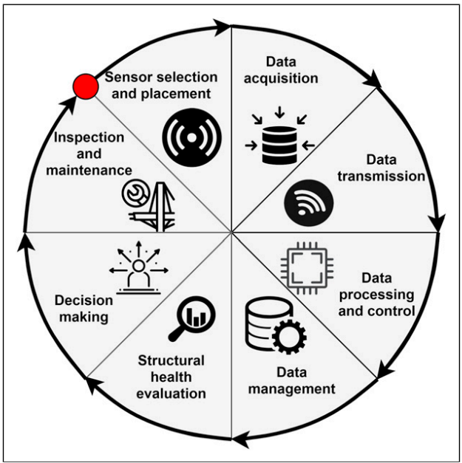

Fig 1 – Components of SHM

Step 1: Sensor Selection and Placement

The first step in SHM is to determine the appropriate sensor placement. This involves identifying critical locations on the structure that are most likely to experience damage. The sensors used for SHM can be of different types, including accelerometers, strain gauges, and piezoelectric sensors, among others. These sensors measure parameters such as strain, vibration, and temperature, which can indicate the health of the structure. The type of sensor used depends on the nature of the structure and the specific damage to be detected.

Step 2: Data Acquisition

The next step involves collecting data from the sensors. This can be done either in real-time or in batches. In real-time data acquisition, the sensor data is collected continuously and analysed in real-time. Batch data acquisition involves collecting the data periodically, for example, daily or weekly, and analysing it offline.

Step 3: Data Pre-processing

After data acquisition, the next step is data pre-processing. The data collected from sensors is often noisy and may contain missing values, outliers, and other errors. This data is cleaned prior to analysis. This involves several techniques such as filtering, interpolation, and imputation. Filtering is used to remove high-frequency noise from the data, while interpolation is used to fill in missing values using linear logic. Imputation is used to estimate the missing values using statistical techniques. ML algorithms require high-quality data to produce accurate results. Pre-processing helps to ensure that the data is clean, normalized, and ready for analysis.

Step 4: Feature Extraction

The next step is to extract relevant features from the pre-processed data. Features are selected based on their ability to provide useful information about the structure's condition. This involves selecting the most important parameters that are relevant to the health of the structure. For example, in the case of a bridge, the relevant features may include the displacement, strain, and frequency response of the structure. Feature extraction is a crucial step in SHM using machine learning as it determines the accuracy of the final prediction. Feature selection can be done manually based on business logic or using ML algorithms such as Principal Component Analysis.

Step 5: Feature Selection

Once the features are extracted, the most relevant features are selected from the original dataset for prediction. This involves analysing the Pearson Correlation between the features and the target variable, which is the structural health status. The features that have the highest correlation with the target variable are selected for further analysis. Feature selection helps reduce the dimensionality of the data and improving the accuracy of the prediction.

Step 6: Model Selection and Training

After feature selection, an ML model that can predict the structural health status based on the selected features is built. There are several types of machine learning algorithms that can be used for SHM, including decision trees, neural networks, and support vector machines. The choice of algorithm depends on the nature of the data and the problem being solved. The model is trained on the data collected from sensors and the selected features.

Step 7: Model Validation

After training the model, the next step is to evaluate its performance using validation techniques such as cross-validation or leave-one-out validation. This helps to determine the accuracy and reliability of the model in detecting damage and predicting its progression.

Step 8: Model Evaluation

Once the model has been built, the next step is to evaluate its performance. This involves testing the model on a set of data that has not been used for training. The performance of the model is calculated using metrics such as accuracy, precision, recall, and F1 score. The model is fine-tuned by optimising the best combination of parameters to improve this metric.

Step 9: Prediction and Decision Making

The final step in SHM using machine learning is to use the model to predict the structural health status based on the real-time data collected from sensors. The predictions are used to make decisions about the maintenance and repair of the structure. For example, if the model predicts that the structure is in poor health, then corrective action can be taken to prevent a potential failure.

Step 10: Implementation

The final step is to implement the SHM system. This involves deploying the sensors, data acquisition system, and ML algorithm in the structure. The system should be integrated with the structure's monitoring and maintenance systems to ensure continuous monitoring and timely maintenance.

Overall, using ML for SHM can support experience-based judgements made by an engineer and improve the accuracy and efficiency of monitoring, enabling early detection of potential issues and reducing the risk of failure or damage to the structure.

**Chapter 6**

**Ensemble Machine Learning Methods**

Ensemble learning is a common and highly effective meta-approach to ML algorithms that aggregate the predictive power of numerous ML models to increase overall model accuracy and prediction for a dataset.

Although infinite number of predictive ensembles can be built by combining different models in different permutations, there are three main methods that are most commonly used on datasets and are known to give high results. These can be easily implemented across a wide range applications and datasets. This reason has led for each of the three models to branch off into multiple other specialized algorithms.

Bagging, Boosting and Stacking are the three main classes of ensemble learning methods, and each of these models are built on a specific underlying fundamental concept of math and code.

Broadly speaking, the ensembles aim to collectively improve the accuracy of predictions and reduce error, variance and bias in the dataset.

1. Bagging fits multiple decision trees on different subsets of the same dataset and averages the predictions.

2. Stacking involves fitting different types of models on the same data and using another model to learn how to best combine the predictions.

3. Boosting involves sequentially adding ensemble members that correct the predictions made by prior models and outputs a weighted average of the predictions.

**1.1 Bagging**

Bagging is a collective machine learning model that divides the input dataset into numerous subsets and builds an independent decision tree on each set. Each tree undergoes binary splitting based on a different combination of input variables for each subset of data. The trees are put together parallelly to build an ensemble that uses majority averaging technique to make decisions and accurately predict the target variable. The multiple trees bring a variety of models to the ensemble and the best subset of features are selected using averages and used to split the node. This fixes the problem of overfitting in data, thereby improving the predictability.

Bootstrap aggregation, is an ensemble learning method that seeks a diverse group of ensemble members by varying the training data.

This often entails training each model on a distinct sample of the same training dataset while utilising a same machine learning algorithm, commonly an unpruned decision tree. The ensemble members' forecasts are then merged using straightforward statistics like voting or average.

The way each dataset sample is prepared to train ensemble members is essential to the methodology. Every model receives a distinct sample of the dataset. The separate models are built using replacement on subsets of data taken at random from the dataset.

If a row is chosen, replacement means that it is returned to the training dataset in case it is chosen again in the same training dataset. This implies that for a specific training dataset, a row of data may be chosen 0 times, 1 times, or many times. This is known as a bootstrap sample. To determine the statistical significance of a data sample, this technique is frequently employed in statistics with small datasets.

A better overall estimate of the desired quantity can be obtained than by directly estimating from the dataset by creating several separate bootstrap samples, estimating a statistical quantity, and then finding the mean of the estimates.

In the same manner, multiple different training datasets can be prepared, used to estimate a predictive model, and make predictions. Better predictions are often obtained by averaging the predictions across the models as opposed to using a single model that is explicitly fitted to the training dataset.

The essential components of bagging can be summed up as follows:

1. Bootstrap samples of the training dataset.
2. Unpruned decision trees fit on each sample.
3. Simple voting or averaging of predictions.

In conclusion, bagging contributes by altering the training data used to fit each ensemble member, which produces competent yet unique models.

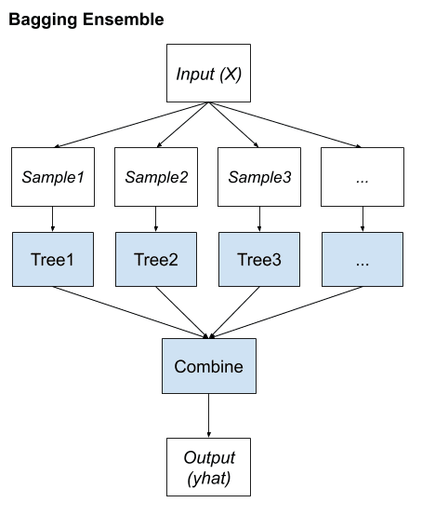

Fig 2 – Flow Chart Depiction of Bagging Algorithm

**1.2 Boosting**

Boosting is an ensemble method that aims to alter the training data in order to draw attention to instances where past fit models on the training dataset have misfit and correct the prediction errors of the prior model. In order to attempt to correct the predictions of the first model, secondary models are fitted and introduced to the ensemble one at a time. The third model then attempts to correct the predictions of the second model, and so on.

This often includes the use of weak learners, which are very basic decision trees that only make one or a few decisions. Although the contributions are weighted in accordance with their performance or competence, the forecasts of the weak learners are blended using simple voting or averaging. The goal is to create a supposedly "strong learner" from a large number of intentionally created "weak learners."

Typically, the training dataset is left unchanged and instead, the learning algorithm is modified to pay more or less attention to specific examples (rows of data) based on whether they have been predicted correctly or incorrectly by previously added ensemble members.

The following is a list of the essential components of boosting:

1. Bias training data toward those examples that are hard to predict.
2. Iteratively add ensemble members to correct predictions of prior models.
3. Combine predictions using a weighted average of models.

The idea of combining many weak learners into strong learners is employed in sightly varying boosting algorithms such as AdaBoost, Gradient Boosting Machines and Stochastic Gradient Boosting (XGBoost)

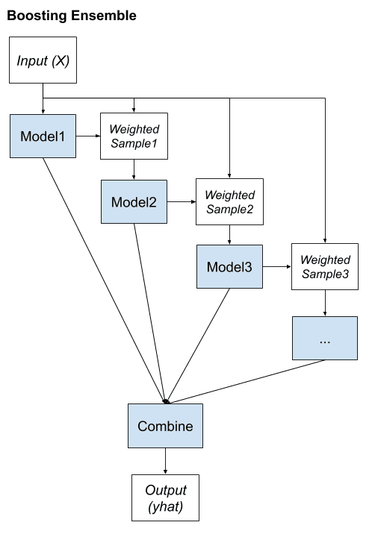

Fig 3 – Flow Chart Depiction of Boosting Algorithm

**1.3 Stacking**

Stacked, is an ensemble method that fits a diverse group of subsets of data by varying the model types fit on the training data and using a model to combine predictions.

Generally, linear regression is used to aggregate prediction for regression and logistic regression is used to aggregate prediction for classification. This encourages the complexity of the model to reside at the lower-level ensemble member models and simple models to learn how to harness the variety of predictions made.

To summarize the elements of stacking:

1. Unchanged training dataset.
2. Different machine learning algorithms for each ensemble member.
3. Machine learning model to learn how to best combine predictions.

Multiple number of ML models can be used to create the stack. Generally, a suite of models that are built in very different ways, ensuring that they make different assumptions and, in turn, have less correlated prediction errors. Many popular ensemble algorithms are based on this approach, including; Stacked Models (canonical stacking), Blending and Super Ensemble.

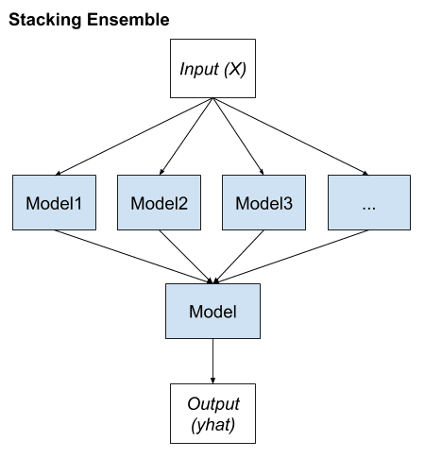

Fig 4 – Flow Chart Depiction of Stacking Algorithm

**Chapter 7**

**Case Study – Prediction of Shear Strength in Steel Fibre Reinforced Concrete Beams**

**7.1 Introduction**

A key application of ML powered Structural Health Monitoring is the prediction of key structural parameters that can be used to estimate the future health of a structure and schedule any maintenance.

Shear strength is one such parameter which greatly affects the stability and safety of structures.

Shear strength of a concrete beam refers to the force that causes two parts of the beam to slide relative to each other along a plane parallel to the cross-section of the beam. In other words, it is the stress that occurs when a force is applied perpendicular to the longitudinal axis of the beam, causing it to bend and deform. The load causes two types of forces to develop within the beam, compression at the top and tension at the bottom. The shear strength occurs in the middle of the beam, where the forces on either side are trying to pull the beam apart. This force is directly proportional to the force applied and inversely proportional to the cross-sectional area of the beam.

As this shear strength causes bending in the beam, it is an important consideration in the design of concrete beams, as it can lead to failure if it exceeds the beam's capacity. Before construction, engineers calculate the maximum shear strength that a beam can withstand and design the beam's dimensions accordingly to ensure that it can safely support the intended load.

Reinforcing the beam is a helpful method to overcome this bending effect. It also helps to increase their strength and durability. As concrete is strong in compression but weak in tension, it can crack and fail under tensile stress. Reinforcing the beams with steel reinforcement bars or fibres helps to counteract this weakness by providing additional strength to the structure.

Steel fibres can be of different shapes, sizes, and types, depending on the intended application and the desired properties of the composite material but they are majorly short, discrete lengths of steel wire or other steel materials that are added to concrete mix in a controlled manner to create a uniform, composite material known as steel fibre reinforced concrete (SFRC). The fibres form a mesh like network that enhances the mechanical properties of a beam such as its resistance to cracking, impact resistance, and fatigue resistance, flexural strength and ductility. The resulting composite material forms a three-dimensional reinforcement network that can also better resist tensile stresses that are induced in the beam due to bending or other types of loading.

Apart from adding steel reinforcement, engineers can periodically monitor shear strength of a structure under varying quantities of load to ensure their safety and integrity. By predicting shear strength, engineers can detect potential problems early on and take corrective action before structural failure occurs.

There are several reasons why predicting shear strength in structures is important for monitoring:

1. Safety: Shear strength can cause structural failure, which can lead to accidents and injuries. By monitoring shear strength, engineers can identify potential safety risks and take appropriate measures to mitigate them.
2. Durability: Shear strength can also cause structural damage over time, which can lead to deterioration and reduced durability of the structure. By predicting shear strength, engineers can assess the long-term durability of the structure and plan for maintenance or repair as needed.
3. Efficiency: Predicting shear strength can also help optimize the design and construction of structures, ensuring that they are efficient and cost-effective. By monitoring shear strength during the construction process, engineers can identify potential problems and make adjustments to improve the design and reduce the risk of failure.

Overall, predicting shear strength in structures is crucial for monitoring their safety, durability, and efficiency. By staying on top of potential problems, engineers can ensure that structures remain stable and reliable over time.

**7.2 Model Development and Workflow**

In the current case study, shear strength of steel fibre reinforced concrete beams is predicted with the help of an Ensemble of Machine Learning models. Independent predictor variables are used to model the result of the target variable, shear strength. As this target variable is given in the dataset, a supervised ML Regression model is implemented. This ML model is developed after compilation of raw data from published literature, data exploration and model selection. The project is approached by defining the problem statement, analysing the dataset in python using data exploration tools, identifying predictor and target variables, dividing the sample space into training and testing set and trying multiple regression algorithms to deploy the best model in production. Firstly, basic ML models are analysed using the eleven input features, next, an ensemble of models are built using the preliminary models that performed well to select a final model producing maximum accuracy for the given dataset. As seen in the figure, the dataset of concrete beams with reinforcement are divided into training and testing sets and ML models are trained on its input parameters to build a predictive model.

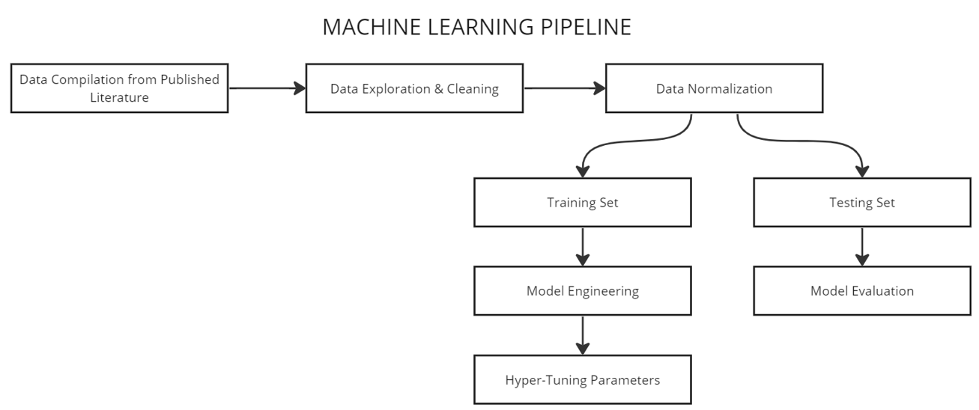

Fig 5 – Flow Chart Depiction End-to-End ML Process

**7.3 Performance Evaluation**

The mathematical efficiency of a model is measured by calculating how well it fits a curve. These are quantified by parameters such as coefficient of determination R2, root mean square error (RMSE), and mean absolute error (MAE). The R2 predicts how efficiently the proposed model can predict the original data. The RMSE is associated with the learning process of the ML model and is the cost function. RMSE and MAE are associated with accuracy and goodness of fit. The mathematical formulae used determine each of these measures are summarized below. A good predictor model is indicated by a R2 value close to 1.00.

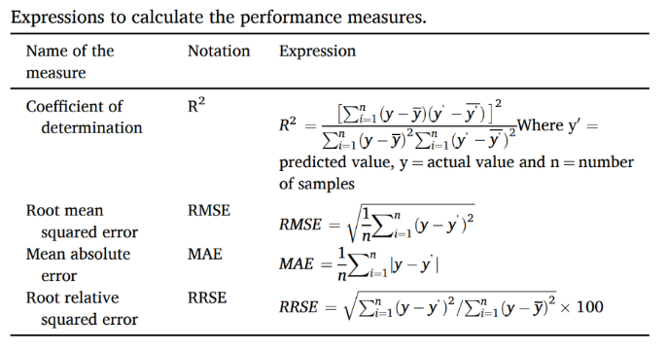

Table 1 – Definition of Performance Metrics

**7.4 Database Used**

This study utilizes the basic concepts of a supervised ML model and uses structural properties divided under three categories; beam, concrete and steel fibres. The features and their statistical parameters are derived to analyse the distribution of each feature. These features are used as predictor variables to forecast shear strength and construct a predictive model to help civil engineers save time and money on cumbersome experiments in the design and construction process. The dataset is a collection of experimental values of reinforced concrete beams that was compiled from multiple research papers. This database was then split into a training and testing set to apply different ML models and the ones providing highest accuracy were optimized to solve this supervised ML Regression problem. The database comprises of over 100 experimental results of concrete beams.

|  |  |
| --- | --- |
|  | Feature Name |
| Beam Dimensions | Width of Beam |
| Height of Beam |
| Effective Depth of Beam |
| Shear span/Effective Depth Ratio |
| Concrete Dimensions | Cylinder Compressive Strength of Concrete |
| Yield Strength of Concrete |
| Steel Fibre Dimensions | Length of Steel Fibre |
| Diameter of Steel Fibre |
| Length/Diameter of steel fibre Ratio |
| Volume Fraction of Steel Fibres |
| Target Feature | Shear Stress as per Experiment |

Table 2 – Features of existing Dataset

**7.5 Basic Data Exploration and Statistical Analysis**

Data analysis and exploration are performed to gauge the spread of the data. Each data point is analysed for its type, and whether it affects the values of the target variable. Python library functions are used to determine the size of the dataset and the number of rows and columns. The exact statistical details of the data such as minimum, maximum, average and standard deviation is found. Each variable is identified as categorical or continuous and the missing values are flagged and fixed. Data Mining is conducted to deal with inadequate and missing data. They are calculated from given data or assumed based upon experience. Finally, columns that don’t affect the target variable are deleted.

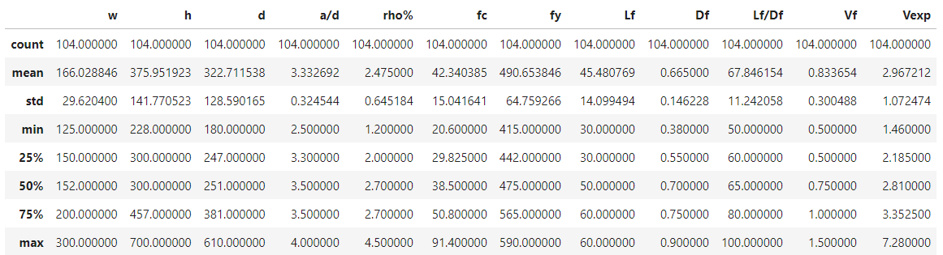

Table 3 – Statistical Analysis of Features

**7.6 Visual Exploratory Data Analysis**

Figure 3 and 4 depict the histogram plots for the Continuous Input Variables. The ideal outcome is a bell curve however, in reality, datasets are rarely perfect. Hence, the variables are accepted as long as there is good distribution across its range.

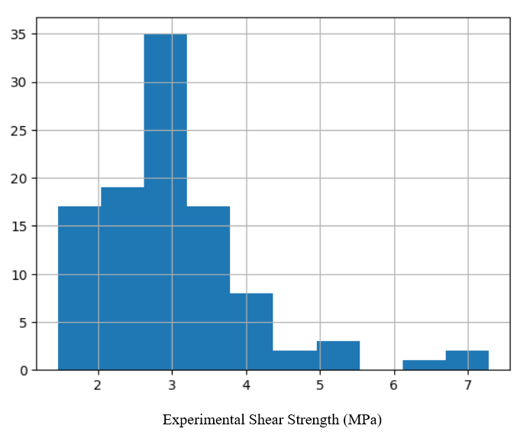

Fig 6 – Distribution of Target Variable

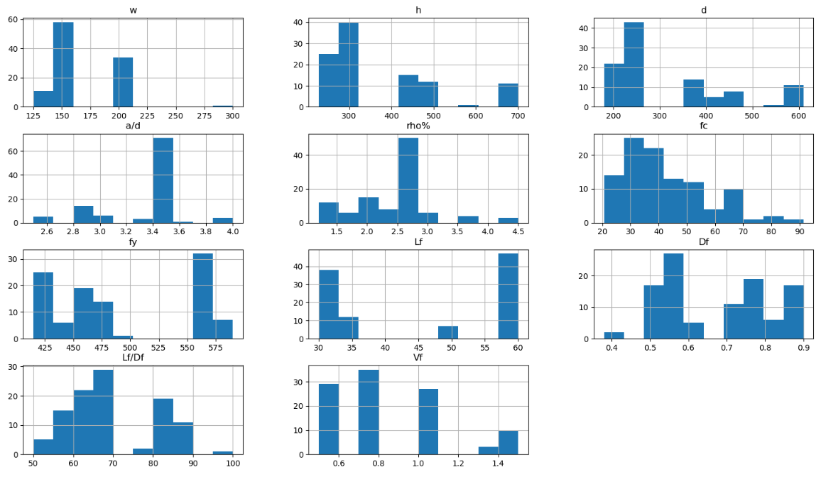

Fig 7 – Distribution of Feature Variables

More importantly, the target variable is analysed and plotted on a histogram. The data distribution of the target variable depicted in Figure 6 and 7 for each dataset has sufficient range and frequency which makes our dataset suitable to build a model upon.

**7.7 Analysis of Input Parameters Affecting Shear Strength**

Since the target and predictor variable is continuous in nature, a correlation plot is used to understand the effect of each predictor variable on the target variable and the relationship between the two. The correlation value can be calculated for any two numeric variables. A negative correlation indicates an inversely proportional relation (downward trend) and a correlation between 0 and 1 indicates a directly proportional relation (upward trend). By studying the correlations between Target variable and all other predictor variables, the intensity of the effects of the predictors can be checked. Variables that are positively correlated and are directly proportional to each other have an increasing trend and variables that are negatively correlated and are inversely proportional to each other have a decreasing trend. An absolute correlation value of 0.5 and above signifies a strong relationship. For the datasets, beam size, maximum aggregate size, longitudinal reinforcement ratio, and shear span effect the target variable the most. Figure X depict the correlation plots for each dataset. A dark violet or light pink color indicates high correlation.

It is observed that for the dataset, beam size followed by the ratio a/d effects shear strength the most. This result was also found by Shahnewaz and Alam [21] , from the study of Meta-model of Optimal Prognosis to identify the important parameters.

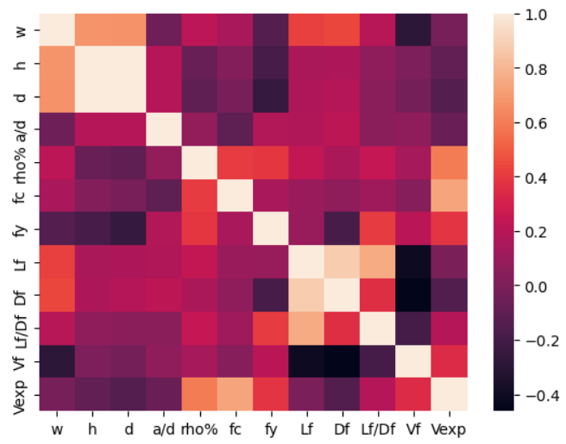

Fig 8 – Heatmap and Correlation Matrix for features

**7.8 Splitting Dataset and Model Selection**

The existing dataset is shuffled, selected at random and divided 2 sets; Training and Testing with a 70-30% ratio. The training set is used to build the model and the testing set is used to validate it. Various ensemble models are applied on the dataset. The model providing with the highest accuracy is selected and optimized. Later, the model is saved and the predicted values are analysed against the original values of the training set. The efficiency produced by each model is depicted graphically below.

|  |  |  |
| --- | --- | --- |
|  | **Ensemble Models Tested** | **R2 Value** |
| BAGGING | Bagging | 76.8% |
| Extra Trees | 81.2% |
| Random Forest | 72.4% |
| BOOSTING | AdaBoost | 75.7% |
| Gradient Boosting | 82.6% |
| OTHERS | Stacking | 47.0% |
| Voting | 80.3% |

Table 4 – R2 Scores of all Ensemble Models

## **7.9 Performance Measures**

## The R2 values corresponding to each ML model for both datasets are analysed and compared with one another. For the dataset, Gradient Boosting Algorithm give maximum accuracy at around 83% followed by Extra Trees Classifier at 81%.

Fig 9 – Performance of each Model

**Chapter 8**

**Results and Conclusion**

This study presents 7 machine learning-based approaches to predict the shear strength of beams with reinforcement. Based on the database, this paper developed ensemble machine learning models using other basic models such as decision trees, linear support vector machine and ridge regression. The dataset is tested on all 9 models and optimized to receive maximum efficiency for prediction. The findings of the present study can be concluded as:

* Gradient Boosting model gave the highest accuracy of **82.6%** to predict shear strength of beams with shear reinforcement. The accuracy of these ML models is satisfactory with respect to our dataset and the comparison of the values predicted by the model with the original laboratory findings supports the applicability of this model for shear strength prediction. New experimental values can be added to the algorithm to make the model more robust.
* Beam size and the ratio a/d effects shear strength the most according to the Pearson Correlation constant. Hence, these values must be calculated cautiously as they greatly affect the target variable.
* The original vs Predicted values of shear strength are depicted in a scatter plot in Figure 1. The line fits almost at a 45-degree angle ensuring close predictions.

Fig 10 – Original vs Predicted Vales of Strength

**Chapter 9**

**Suggestion for Future Work**

Structural health monitoring (SHM) is a field that focuses on the detection, diagnosis, and prognosis of structural damage or deterioration. While machine learning has been a valuable tool in SHM, there are other technologies and approaches that could shape its future. Here are some examples:

1. Advanced sensors: The development of more advanced sensors, such as fibre optic sensors and piezoelectric sensors, can provide more accurate and detailed information about the health of a structure. These sensors can measure strain, temperature, vibration, and other parameters that can indicate the presence of damage.
2. Robotics: The use of robots to inspect and monitor structures can be a game-changer in SHM. Robotic systems can access hard-to-reach areas, perform inspections at high speeds and with high accuracy, and provide real-time data.
3. Wireless sensor networks: The deployment of wireless sensor networks can enable continuous monitoring of large structures such as bridges, buildings, and dams. These networks can communicate data wirelessly, reducing the need for costly and time-consuming physical inspections.
4. Structural health modelling: Modelling the behaviour of a structure can provide insights into its health and performance. By combining data from sensors, analytical models, and simulation tools, engineers can predict the behaviour of a structure under different conditions and identify potential issues before they occur.

In summary, the future of SHM beyond machine learning will likely involve the integration of multiple technologies and approaches to improve the accuracy, speed, and efficiency of monitoring and diagnosing structural damage.

# References

|  |  |
| --- | --- |
| [1] | A. A. E. T. Noel AB, " Structural health monitoring using wireless sensor networks: a comprehensive survey," *IEEE Commun Surv Tutor,* vol. 19, pp. 1403-1423, 2017. |
| [2] | G. B. T. G. Arcadius Tokognon C, "Structural health monitoring framework based on internet of things: a survey," *IEEE Internet Things,* no. 4, pp. 619-635, 2017. |
| [3] | M. Y. A. P. Gomes GF, "A review of vibration based inverse methods for damage detection and identification in mechanical structures using optimization algorithms and ANN," *Arch Comput Methods Eng,* vol. 26, pp. 883-897, 2019. |
| [4] | F. W. a. Q. P, "Vibration-based damage identification methods: a review and comparative study," *Structural Health Monitoring,* pp. 83-111, 2010. |
| [5] | F. D. a. F. MQ, "Computer vision for SHM of civil infrastructure: from dynamic response measurement to damage detection – a review," *Engineering Structures,* vol. 156, pp. 105-117, 2018. |
| [6] | G. M. a. N. M. Ghiasi R, "Comparative studies of metamodeling and AI-based techniques in damage detection of structures," *Advance Engineering Softwares,* vol. 125, pp. 101-112, 2018. |
| [7] | N. F. G. M. Kerle N, "UAV-based structural damage mapping: a review," *ISPRS Int J Geo-Inf,* 2019. |
| [8] | C. H. Z. (. G. Hou L, "Deep learning-based applications for safety management in the AEC industry: a review," *Applied Sciences,* 2021. |
| [9] | S. Z. X. Y. Sun L, "Review of bridge structural health monitoring aided by big data and artificial intelligence: from condition assessment to damage detection," *Structural Engineering,* 2020. |
| [10] | B. M. a. D. T, "Proceedings of the International Conference on Computing AdvanApplication of Neuro-GA Hybrids in Sensor Optimization for Structural Health Monitoring," *Proceedings of the International Conference on Computing Advancements. Dhaka Bangla deshACM,* pp. 1-7. |
| [11] | M. V. a. A. MH, "Optimal sensor placement for structural, damage and impact identification: A review," *Structural Durability Health Monitoring,* pp. 287-323, 2013. |
| [12] | C. E. a. M. S. Capellari G, "Optimal sensor placement through bayesian experimental design: effect of measurement noise and number of sensors," 2016. |
| [13] | C. X. S. L. Ren P, "Incremental Bayesian matrix/ tensor learning for structural monitoring data Imputation and response forecasting," *Mechanical System Signal Process,* vol. 158, 2021. |
| [14] | S. M. a. K. A. Martinez-Luengo M, "Data management for structural integrity assessment of offshore wind turbine support structures: data cleansing and missing data imputation," *Ocean Engineering,* pp. 867-883, 2019. |
| [15] | L. J. a. H. H. Fan G, "Lost data recovery for structural health monitoring based on convolutional neural networks," *Structural Control Health Monitoring,* 2019. |
| [16] | B. T. C. H. Li Y, "A large-scale sensor missing data imputation framework for dams using deep learning and transfer learning strategy," 2021. |
| [17] | A. S. R. A. Akintunde E, "Full scale bridge damage detection using sparse sensor networks, principal component analysis, and novelty detection," 2019. |
| [18] | Z. H. Z. Q. Zhou Q, "Structure damage detection based on random forest recursive feature elimination," *Mech Syst Signal Process,* pp. 82-90, 2014. |
| [19] | W. Z. W. L. Zhang L, "Machine learning based real time visible fatigue crack growth detection," 2021. |
| [20] | O. K. a. Y. T. Kohiyama M, "Detection method of unlearned pattern using support vector machine in damage classification based on deep neural network," *Struct Control Health Monit,* 2020. |
| [21] | A. M. S. M, "Genetic algorithm for predicting shear strength of steel fiber reinforced concrete beam with parameter identifictaion and sensitivity analysis," *Journal of Building Engineering, 2020. ,* 2020. |
| [22] |  |
| [23] |  |